**Hands On Session**

**SPRING LEARN - SPRING BOOT WEB PROJECT**

**Project Overview**

A simple Spring Boot web project created for learning and demonstration purposes.

**Group:** com.cognizant

**Artifact:** spring-learn

**Spring Boot Version:** 3.2.5

**Java Version:** 17

**Dependencies:** Spring Web, Spring Boot DevTools

**Steps**   
**1. Build the Project:** Open terminal and navigate to the project directory:  
cd path/to/spring-learn

mvn clean package

**2. Import into Eclipse :**File > Import > Maven > Existing Maven Projects > Browse to the project folder > Finish

**3. Run the Application :**Right-click SpringLearnApplication.java > Run As > Java ApplicationThe application starts on port 8080 by default.

**4. Verify Startup :**Check the console for log messages like START and END and the Spring Boot banner.

**Project Structure**

* src/main/java - Application source code
* src/main/resources - Application configuration
* src/test/java - Test code
* pom.xml - Maven configuration

**Screenshots**

1. **SpringLearnApplication.java in Eclipse**

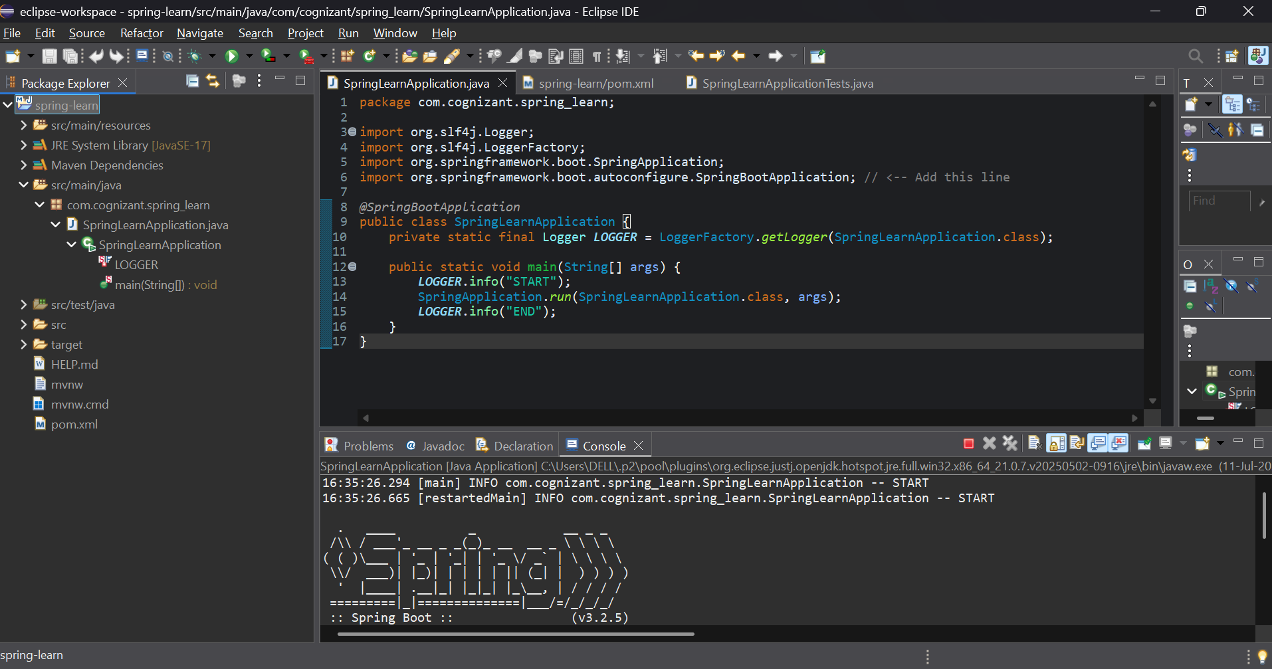

1. **Spring Boot Console Output**

